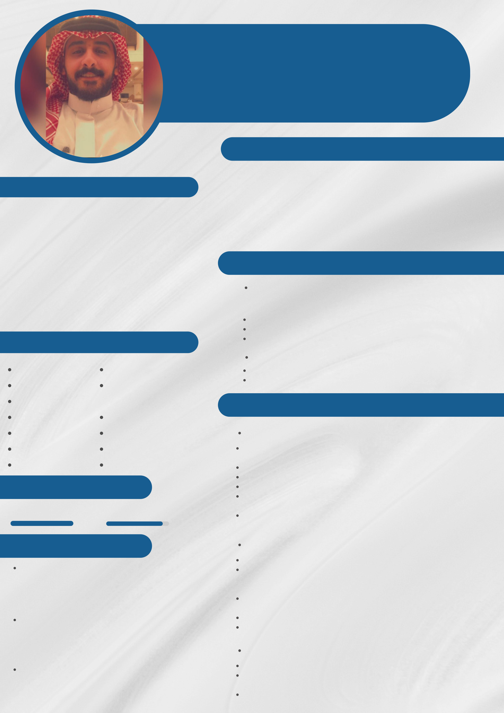

OSAMA ALSALAFI   
M E C H A T R O N I C S & S O F T W A R E E N G I N E E R C E R T I F I E D B Y S C E ( 8 2 0 2 4 0 )

ABOUT ME

CONTACT

**Phone**  +966 59 140 3283

**Email**  os.alsalafi@gmail.com

Software Engineer, with 1 year of experience in the field of Technical & software engineering, and certified from Saudi council of engineers, interested in the field of IoT development, Solutions development, Machine & Deep learning, new technologies for automation management systems, Always up for a challenge and working hard to make it happen. I enjoy being busy and working on all sorts of projects.

|  |  |  |
| --- | --- | --- |
| **Address** | Riyadh, Saudi Arabia | EDUCATION |

**Linkedin**  https://www.linkedin.com/i

n/osama-alsalafi-275157197

**Github**  https://github.com/osalsalafi

EXPERTISE

***International Islamic University Malaysia | 2021***

Bachelor degree in Mechatronics Engineering, IIUM, Malaysia, Sep 2016-Oct 2021   
 First class honor   
 Grade : 3.66 out of 4   
 Dean's list student in 6 semesters

***English Language Company Malaysia | 2015***

|  |  |  |  |
| --- | --- | --- | --- |
| Python\django | Quick learner | Present | Achieved higher intermediate level certificate |
| C\C++ | written and verbal | Achieved 5.5 score in IELTS in 2016 |
| Arduino\Raspi | communication skills | EXPERIENCE |
| Microsoft Office | Problem solver |
| Typing Skill | Logical thinker | ***Sales Engineer | Fastnet IoT | KSA, Riyadh*** |
| May 2022 |
| Git/Github | Result oriented | Apr 2022 | present more that 50 solutions in smart homes industry for our |
| clients |
| HTML/CSS | Self-motivated |
| Manage billing and delivery of solid products |
| LANGUAGE | | Develop more than 100 BOQs for clients |
| Acquire new customers by winning them over other competitors. |
| Support Technical team when necessary by utilizing my solid |
| Arabic | English | technical and software backgrounds. |
| Developing solutions by using ETS software for wired systems & |
| 100% | 90% |
| third party apps for wireless solutions. |
| CERTIFICATES | |
| ***Technical Engineer | Fastnet IoT | KSA, Riyadh*** |
| Nov 2021 |
| Python developer | | Sep 2021 | Supervise the maintenance of the karts, and the Arcades |
| Follow up with contracted companies that support Osool in |
| *Saudi Federation For Cybersecurity, Programming* | | either Karting system "Racefacer" or Kiosk system "Odoo', |
| *and Drones (SAFCSP)* | | 'Semnox' and other companies. |
| *solved more than 118 challenges in CoderHub and getting* | | Leads the mechanics to check the usual maintenance of the |
| *52 rank among 4000 programmer* | |
| karts, and make preventive maintenance. |
| Machine Learning Using Python | | Perform IT troubleshooting when required during emergencies |
| Solicit observations from operation |
| *JeelAidm, Jeddah, KSA* | |
| *4 Weeks of intensive courses about data analysis and* | |
| *machine learning using python language with introduction* | | ***Software Engineer Trainee | HERR | KL, Malaysia*** |
| *to deep learning using tensorflow and sklearn libraries* | | Jul 2021 |

Application Development Using Python *Hsoub Academy*   
*more than 50 hours course,* 8 different projects and using django frameword

It was my internship period with them as a trainee   
I developed with them a python code for automated speech-based depression detection using deep learning method   
I created with them a web app to publish their project